ARTIFICIAL INTELLIGENCE LAB — LAB 4
Name: Abdul Raheem | Roll Number: 041
Course: Artificial Intelligence Lab

Introduction
This report documents the three Lab 4 tasks using the supplied campus-routing graph. The tasks cover manual A* evaluation, a controlled comparison between A* and Uniform Cost Search (UCS), and an experiment showing the effect of an overestimating heuristic.

Graph and Heuristic Values
Directed weighted edges: S → A (1), S → B (4), A → C (2), B → G (5), and C → G (3).
Start node: S. Goal node: G.
Original heuristic: h(S)=5, h(A)=4, h(B)=4, h(C)=2, h(G)=0.
A* evaluation function: f(n)=g(n)+h(n), where g(n) is the cost from the start node and h(n) estimates the remaining cost.

Task 1 — Compute g, h and f for the First Three Expansions
Expansion 1: Select S. Initially g(S)=0, h(S)=5, and f(S)=0+5=5. S is the only frontier node.
Successors of S:
- A: g(A)=g(S)+cost(S,A)=0+1=1; h(A)=4; f(A)=1+4=5.
- B: g(B)=g(S)+cost(S,B)=0+4=4; h(B)=4; f(B)=4+4=8.
Frontier after S: A(g=1,h=4,f=5), B(g=4,h=4,f=8). A is selected next because f(A)=5 is less than f(B)=8.
Expansion 2: Select A. g(A)=0+1=1, h(A)=4, and f(A)=1+4=5.
Successor of A:
- C: g(C)=g(A)+cost(A,C)=1+2=3; h(C)=2; f(C)=3+2=5.
Frontier after A: C(g=3,h=2,f=5), B(g=4,h=4,f=8). C is selected next because f(C)=5 is less than f(B)=8.
Expansion 3: Select C. g(C)=g(A)+cost(A,C)=1+2=3, h(C)=2, and f(C)=3+2=5.
Successor of C:
- G: g(G)=g(C)+cost(C,G)=3+3=6; h(G)=0; f(G)=6+0=6.
Frontier after C: G(g=6,h=0,f=6), B(g=4,h=4,f=8). G is selected next because f(G)=6 is less than f(B)=8.
Summary: The first three expanded nodes are S, A, and C. The resulting route is S → A → C → G with total cost 1+2+3=6.
Expansion | Node | g(n) | h(n) | f(n)
1 | S | 0 | 5 | 5
2 | A | 1 | 4 | 5
3 | C | 3 | 2 | 5

Task 2 — Compare A* and UCS on the Same Graph
The graph and endpoints were kept the same. A* used the supplied heuristic, while UCS used h(n)=0 for every node. A node was counted as expanded when its successors were examined. The goal node G was logged but not counted as expanded; stale queue entries were ignored.
Measure | A* (given h) | UCS (h=0) | Interpretation
Returned path | S→A→C→G | S→A→C→G | Same route
Path cost | 6 | 6 | Both costs agree
Independent sum | 1+2+3=6 | 1+2+3=6 | Matches reported cost
Processed-node trace | S, A, C, G | S, A, C, B, G | UCS also processes B
Expanded nodes | S, A, C | S, A, C, B | Goal excluded from count
Expansion count | 3 | 4 | A* expands one fewer node
Stale entries skipped | 0 | 0 | None in either run

Interpretation: Both algorithms found the optimal path at cost 6. In this particular experiment, A* expanded 3 nodes, whereas UCS expanded 4. This measured result supports the conclusion that the supplied heuristic reduced expansions on this graph; it does not prove A* always expands fewer nodes on every problem.
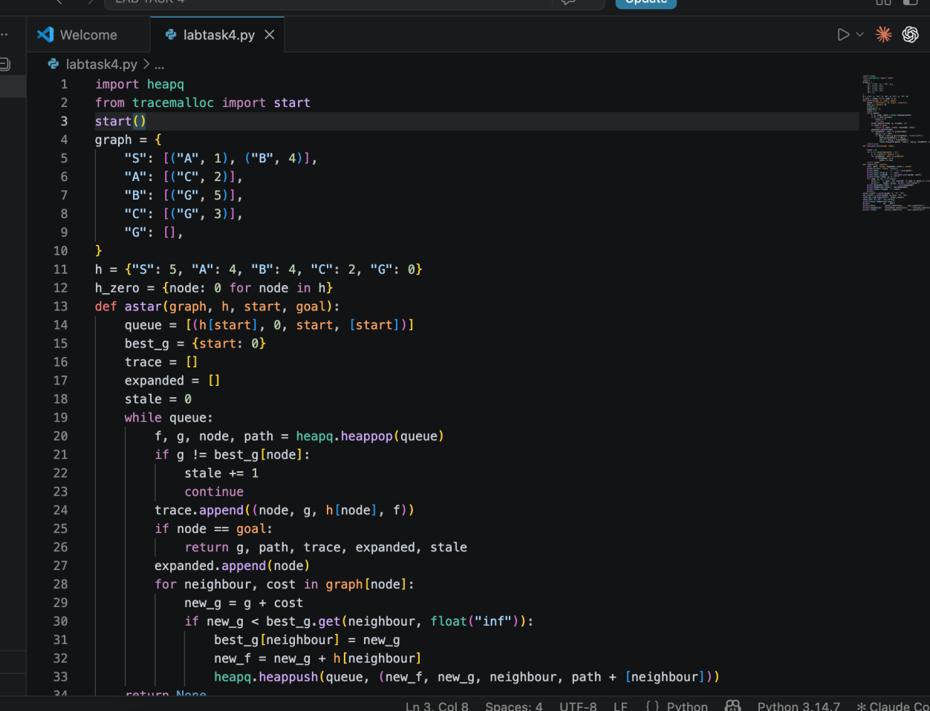
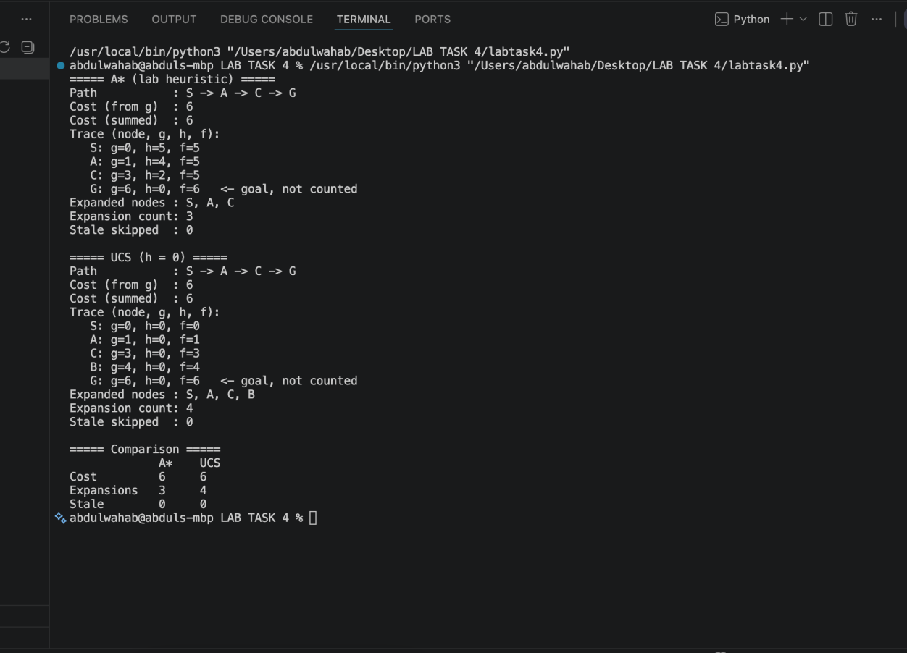

Task 3 — Overestimating Heuristic Experiment
Only one heuristic value was changed: h(C) was increased from 2 to 10. All graph edges, other heuristic values, start node S, and goal node G remained unchanged.
Original h(C)=2. C's true remaining cost is 3 because the only edge from C to G costs 3. The original heuristic does not overestimate this remaining cost.
Modified h(C)=10. Since 10 is greater than the true remaining cost 3, this heuristic is inadmissible.
Measure | Original h(C)=2 | Modified h(C)=10 | Change
Returned path | S→A→C→G | S→B→G | Path changes
Path cost | 6 | 9 | Increases by 3
Expanded nodes | S, A, C | S, A, B | C is not expanded in modified run
Expansion count | 3 | 3 | Same count
Stale entries skipped | 0 | 0 | No change

Explanation: With h(C)=10, f(C)=g(C)+h(C)=3+10=13, while B has g(B)=4, h(B)=4, and f(B)=8. A* therefore selects B and then reaches G on the route S → B → G with cost 4+5=9, before expanding C. The alternative route through C costs 1+2+3=6 and is optimal, so this experiment demonstrates that an overestimate can cause A* to return a suboptimal path. An overestimate removes the general optimality guarantee even if a different test happens to return the optimal route.
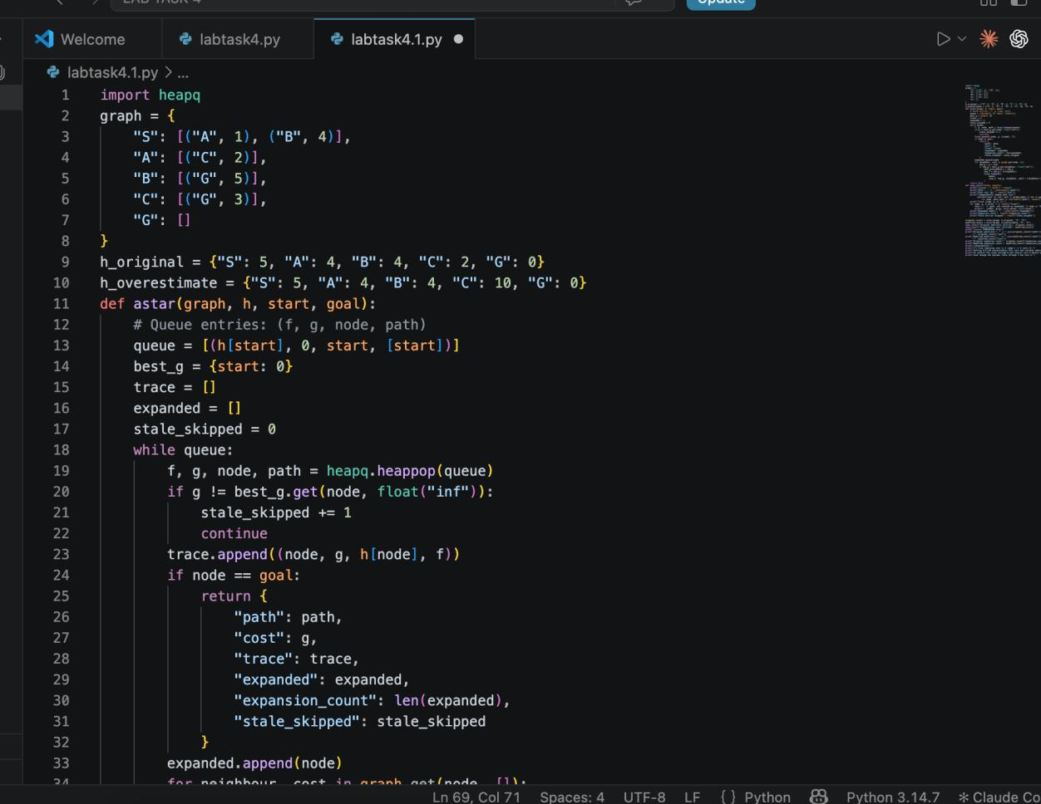
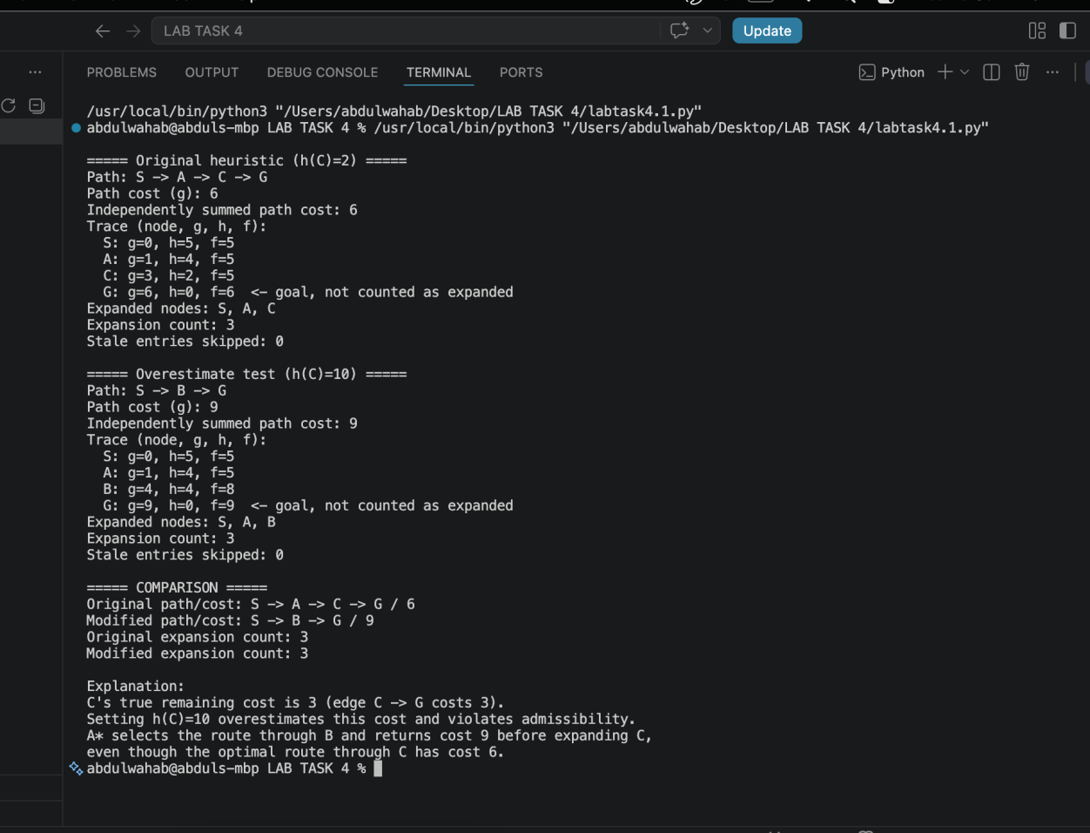

Overall Conclusion
The manual trace in Task 1 identified S, A, and C as the first three expansions. Task 2 showed that A* and UCS both returned the optimal cost-6 route, with A* expanding one fewer node under the specified counting rule. Task 3 showed that changing only h(C) from 2 to 10 caused A* to return the cost-9 route through B, even though a cost-6 route exists through C. These results highlight the importance of selecting an admissible heuristic when optimality is required.

Reflection
I learned how g(n), h(n), and f(n) guide A* node selection and how UCS provides a zero-heuristic comparison. The overestimate test demonstrated that heuristic quality can affect the returned route. In future tests, I would check heuristic admissibility and consistency and compare results using the same expansion-counting convention.

